Barry Town United Walking Football Festival

28 August 2022,

Jenner Park Barry CF62 8NA

Thank you for entering the Barry Town United Walking Football Festival on 28 August 2022. We appreciate your support and look forward to meeting you and to a successful and enjoyable day that we aim to turn in to an annual event.

We have put together this information pack to help the event run smoothly and safely for all. This pack should contain everything you need for the festival but if you think we’ve missed something please let us know by emailing us at [duffersunited@virginmedia.com](mailto:duffersunited@virginmedia.com)

Additional information about Barry Town United Walking Football, this event, updated copies of this document and frequently asked questions can be found on our website at [www.duffersunited.co.uk](http://www.duffersunited.co.uk)

**Pack Contents:**

* Venue location,
* Parking,
* Images of Jenner Park
* Barry & Barry Island
* Venue facilities (Jenner Park)
* Essential footwear
* Festival Qualifying Criteria
* Times and event format
* Presentation
* Essential Equipment
* First Aid
* St John Ambulance
* Defibrillators
* Risk assessment
* Health and safety
* Referees & Laws
* Contact details
* Annexes

**Venue Location**

All games will be played at the home ground of Barry Town United. The full address of the venue is:

Jenner Park

Gladstone Road,

Barry

CF63 1BJ

<https://www.bing.com/maps?q=jenner+park+barry&form=ANNTH1&refig=934b1708872a45778cb4abd3c50beb56>

Jenner Park has two entrances one on Barry Road and another on Gladstone Road (A4055). Both gates will be open on the day.

**Parking**

There are no parking facilities at Jenner Park however there is plenty of free on street parking around the ground. The ground is in a residential area, please park responsibly with regard to the needs of residents.

Although you can park at the Barry Road and Gladstone Road ends of the ground there is likely to be more free parking opportunities at the Gladstone Road end of the ground.

**Images of Jenner Park**

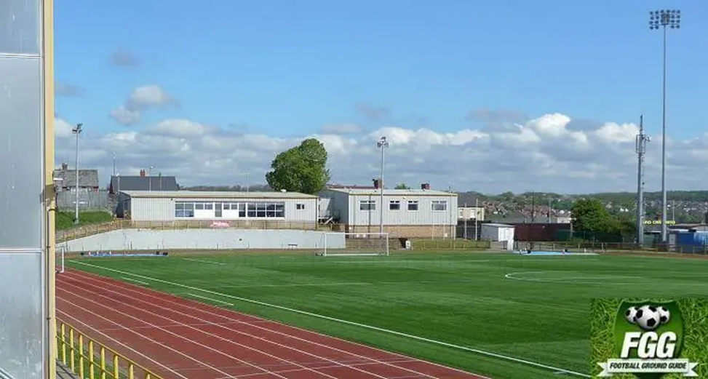

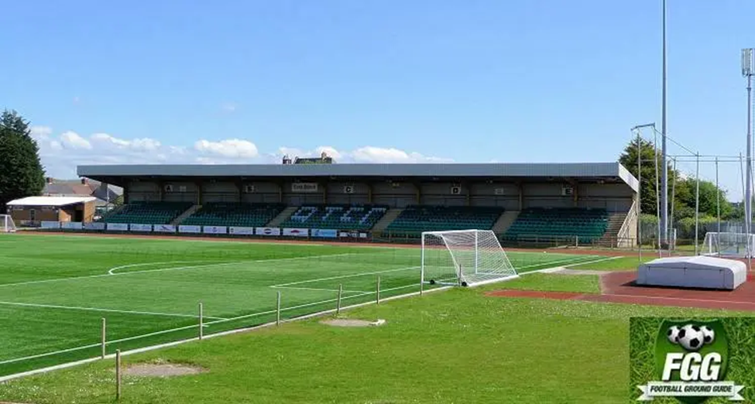

**Barry & Barry Island**

Barry (Welsh: Y Barri) is a town in the Vale of Glamorgan, Wales, on the north coast of the Bristol Channel approximately 9 miles (14 km) south-southwest of Cardiff.

Barry is a seaside resort, with attractions including several beaches (sand and pebble) and the Barry Island Pleasure Park.

If you plan to bring family with you Jenner Park is approximately 2 miles from Barry Island

If you are travelling from afar and need accommodation there are a number of hotels and guest houses in Barry, Cardiff and the Vale Of Glamorgan and several caravan parks

For more information about Barry and the surrounding area see <https://www.visitthevale.com/towns/barry-barry-island>

**Venue Facilities (Jenner Park)**

**The Pitch**

All games will be played on the 3G surface at Jenner Park. **Specific footwear is a requirement (see below)**

**Player Changing Rooms**

Changing Rooms and showers are available for players at the Barry Road end of the ground. Please note that the player changing rooms are built to accommodate two eleven a side squads so space will be limited at certain times.

Separate changing rooms and showers will be available for referees

**Seating and Shelter**

Jenner Park has two covered fully seated stands either side of the pitch. There is ample seating at the ground for players and spectators.

**Toilets**

There are both male and female toilet facilities next to the pitch, inside the changing rooms and in the social club

**Social Club**

There is a Social Club at the ground which welcomes visitors. The social club is situated above the changing rooms at the Barry Road end of the ground and will be open all day to purchase drinks and snacks.

**Food & Beverages**

We plan to have a burger van selling teas and coffees and ice cream van on site for the day and during the presentations at the end of the games a free buffet will be available in the social club

**Essential Footwear**

All games will be played on Barry Town United 3G pitch. **There is a strictly enforced footwear rule at Jenner Park**. Please make sure that all your players and anyone requiring access to the pitch has the correct footwear (see illustration)

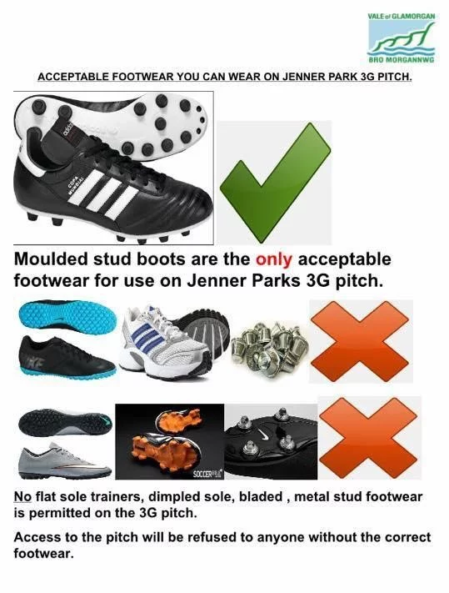

The only footwear permitted on the pitch are moulded round stud boots. Please note all footwear will be checked to ensure it complies with the above before each game.

Without exception, anyone not wearing the correct footwear as shown above will be refused access to the playing surface at Jenner Park. Please make sure all your players are aware of this requirement.

**Festival Qualifying Criteria**

The festival is open to male only, female only or mixed gender walking football teams. To qualify to play at our event the following must be satisfied:

* **Over 50**, all players must reach age 50 between 1 January 2022 and 31 December 2022.
* **Over 60**, all players must reach age 60 between 1 January 2022 and 31 December 2022.

Players who satisfy the over 60 criteria can play at over 50.

Each club invited to play at our festival is permitted to register a maximum of 10 players per team. Because circumstances change, we will permit changes to team players prior to the start of the festival provided those changes are reported to Barry Town United no later than during the registration process on Sunday 28 August 22

All players must bring some form of photo ID as random checks may take place to ensure compliance with the above

**Times and Event Format**

Event start times:

Team registration: 9:45am

First game kick off: 10:30am

Games including finals: planned to run from 10:30am to 3:30pm

Presentations: 4pm (approximately)

A full event timetable will be posted on our “Tournament 2022” page at [www.dufferesunited.co.uk](http://www.dufferesunited.co.uk)

**Pitches:**

4 pitches will be in use throughout the day as follows:

Pitch 1 Over 50 group 1

Pitch 2 Over 50 group 2

Pitch 3 Over 60 group 1

Pitch 4 Over 60 group 2

Each pitch number will be clearly displayed on the goalposts

**Event Format**

There will be a maximum of 12 teams in each age group with the age groups playing on two pitches simultaneously. All teams in assigned to a specific pitch will play each other once.

3 points will be awarded for a win and 1 point for a draw

The winners and runners up in each group will play off against the winners and runners up on the other pitch in their age group for a place in the final. In the event of a points tie at the group stage, goal difference will be applied first and if still tied goals scored will be applied.

If necessary, penalties will be used to decide the outcome of the play offs and finals

The maximum match duration will be 12 minutes without a half time break

To ensure that timings are adhered to all games will start and finish on a klaxon/whistle. Teams will get a 1-minute warning before each game, but each game will start on the 2nd klaxon/2nd whistle whether the teams are ready or not. If any team fails to be on the pitch for the start of the game, they will start 1 nil down.

A full match timetable will be posted on our “Tournament 2022” page at [www.dufferesunited.co.uk](http://www.dufferesunited.co.uk)

Four pitches will be available throughout the day so any teams who would like to play each other can use a free pitch at their own risk until the presentations commence.

**Presentations**

After the completion of the finals a presentation will be held in the social club with trophies presented to the winners and runners up of both age groups.

During the presentation the social club bar will be open to purchase refreshments and a buffet will be provided free of charge for anyone who attends the presentations.

We hope everyone will join us in the social club to celebrate a successful event and acknowledge the winners and runners up

**Essential Equipment**

Barry Town United will provide sufficient footballs for each pitch

All pitches will be of equal size, and set up as agreed with the match day referees

**In addition to the essential footwear requirement above** each team must ensure or provide the following:

* Shin pads are compulsory for each player
* Coloured bibs for all players in case of a colour clash
* Coloured bibs for all substitutes
* Player personal information, emergency contact information and details of health needs in case of emergency
* Player medication as needed
* Barry Town United will have a first aid kit on site however each club must provide its own first aid kit with your players needs in mind
* Barry Town United will have 2 defibrillators on site (see below)

**First Aid**

We will do everything we can to make sure that event is safe, and everyone has fun, but it is important to remember that accidents happen. There may be injuries and illness, they can happen anywhere and at any time, but we are particularly aware of them in walking football.

Barry Town United Walking Football will do what it can on the day but keeping everyone safe is all of our responsibilities and each club is responsible for ensuring that they are aware of the issues and needs of their players and representatives and have one qualified first aider on site at all times

Barry Town United will provide a nominated first aider for the day who will co-ordinate and assist each club with any first aid needs

**St John Ambulance**

At the time of writing, Barry Town United are in the process of negotiating terms with St John Ambulance to ensure we have additional qualified health professionals at Jenner Park throughout the day

**Defibrillator locations**

In accordance with Football Association of Wales guidelines Jenner Park has a working defibrillator pitch side.

There is an additional defibrillator in the social club

**Risk assessment, health and safety info, insurance**

All teams must ensure that they have suitable public liability insurance in place

Jenner Park is used to host football matches across a wide range of age groups and is currently owned by Vale of Glamorgan Council. Barry Town United use Jenner Park as its home ground. All necessary risk assessments will be reviewed prior to the festival to ensure that the venue is safe, and risks are minimised

The pitch and facilities will be checked before the first game and periodically throughout the day. Any issues should be brought to the immediate attention of one of the Barry Town United Walking Football Team Managers. A Barry Town United Walking Football Team Managers will be allocated to each pitch

Representatives from Barry Town United will be available on the day to answer any questions about the venue and its facilities.

**Referees & Laws**

We will provide qualified referees.

As the event is in Wales, we will be following the Wales Walking Football Federation Laws of the game. The referees will outline the laws at the start of the event.

A copy of the laws can be found on the “Festival 2022” page of our website at [www.duffersunited.co.uk](http://www.duffersunited.co.uk). Please make every effort to read them and convey them to your team before you attend.

Please respect the referees and their decisions at all times. The decision of the referee is final.

**Conduct**

Barry Town United Walking Football believes in full inclusivity and the involvement of the community and family members in sport. There is no entrance fee to the ground on the day so families and children, as well as members of the public may be present. As such we expect the highest standards of conduct and behaviour of everyone attending the event

A code of conduct document is included as an annex at the end of this document. Please ensure anyone linked to your club has read and understood the code before attending our festival.

**Anything Else?**

If there is anything you think we have missed from this document or anything that would develop it further, please email [duffersunited@virginmedia.com](mailto:duffersunited@virginmedia.com)

We will not be issuing revisions to this document to each club. Any future updates to this document will be published on the “Tournament 2022” page of our website at [www.duffersunited.co.uk](http://www.duffersunited.co.uk) so please check for changes before you attend on 10 July 2022.

**Barry Town United Walking Football Contact Details**

Email: [duffersunited@virginmedia.com](mailto:duffersunited@virginmedia.com)

Website: [www.duffersunited.co.uk](http://www.duffersunited.co.uk)

Facebook: <https://www.facebook.com/Duffers-United-Walking-Football-111678004761329>

Chairperson: Andrew Weeks contacted via [duffersunited@virginmedia.com](mailto:duffersunited@virginmedia.com)

Secretary: Paul Edwards contacted via [duffersunited@virginmedia.com](mailto:duffersunited@virginmedia.com)

**Finally**

Thank you for taking the time to read all of the above. We are looking forward to the day and hope you are too.

We hope you have a relaxed, friendly competition and a celebration of Walking Football at Jenner Park that leaves you looking forward to our next event

Yours

**The committee and members at Barry Town United Walking Football** [www.duffersunited.co.uk](http://www.duffersunited.co.uk)

**Annexes**

**Spare Entry Form**



**Code of Conduct**

